# Usability testing report

Tasks as described in file tasks.docx

## Task 1

* search: ok
* see job posting details: ok
* open company website: ok

## Task 2

* register as company: ok, **Problem 1**
* log in: ok, **Problem 2**
* find my account page: ok
* log out: ok

## Task 3

* login with „adidasmail@mail.ch“: ok,
* create new job posting: ok, **Problem 3**
* look at all adidas postings: ok
* sort them according to approvement status: ok
* edit rejected posting: ok
* delete another posting: ok
* edit approved posting: **Problem 4**
* second language “Mandarin”: skipped
* my account: ok
* change password to “ad1das”: ok
* change contact name: skipped

## Task 4

* log in with “admin”: ok
* find admin area: ok, **Problem 5**
* verfiy adidas: not possible, skipped in task 3
* reject company: ok
* approve job posting/reject job posting: ok, **Problem 6**
* log out: ok

## Task 5

* log in with [baduser@gmx.com](mailto:baduser@gmx.com): ok, **Problem 7**
* change account description: ok
* log out: ok

## Problems

**Improvements for future usability tests:**

Problem with skipped tasks: Tasks would be less skipped, if there is a new line for every single task. But only a few tasks were skipped, so it was not a big problem.

**Problem 1**

Registration as company: which fields are required/optional?

*Solution:* Added * to mark required fields.

**Problem 2**

After registration, the user is not logged in.

*Solution:* We did not change that policy. Many other websites have this policy too. It’s even a bit a spam protection. If we add an email confirmation system in future, then this problem is easy solved.

**Problem 3**

Offer valid until was not clear.

*Solution:* Added description/label which is more clear

**Problem 4**

In the “My Job postings” site the test user clicked on the title of a job posting to edit it. But this opens the normal job posting details page, where the user cannot edit the job posting. Instead he has to use the “Edit”-Button directly in the “My Job postings” site.

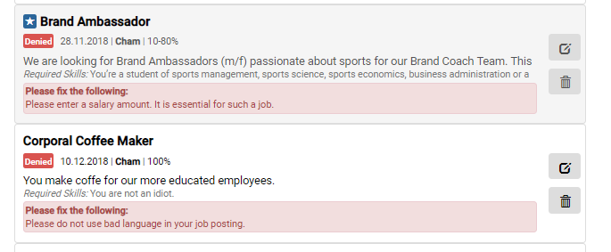

Click on "Brand Ambassador" to open the details page. There you cannot edit the posting. Use for editing the edit button (red circle).

*Solution:*

**Problem 5:**

Finding the admin area is not obvious (top right corner).

*Solution:* We found it important, that a signed in admin can also look at the site and sees the same things as a normal student does. So we made a clear distinction between admin/normal area. Because the admin is not a normal user and has to use the platform often, he will learn to find the admin area (only 1 click from every page). So we did not change anything.

**Problem 6:**

All jobs and companies which the admin has to accept/decline are on the same page. On the upper part the jobs and on the lower part the companies. The position of the jobs and the companies is not intuitive. It is hard to find the “border” between jobs and companies, as all of them have a similar “grey box”. This means that for many entries, the layout becomes confusing.

*Solution:* Complete redesign of the admin area. There are now 2 separate pages for job postings/companies, directly accessible from the admin dropdown.

**Problem 7:**

If you are signed in, you do not see directly who you are. You have to access the “My account” page for that.

*Solution:* In the usability test, there was a lot of signing in and out for just a single user. This is confusing, if it is not clear, for which company you are signed in. But for normal usage, a company has only one account. So if you are signed in, it is clear. So we decided to take no action.